**DBMS ASSIGNMENT 12**

**CLASS: TE B**

**ROLL NO: 322008**

**Problem Statement:** Implement Map reduces operation with suitable example using MongoDB.

**Screenshots:**

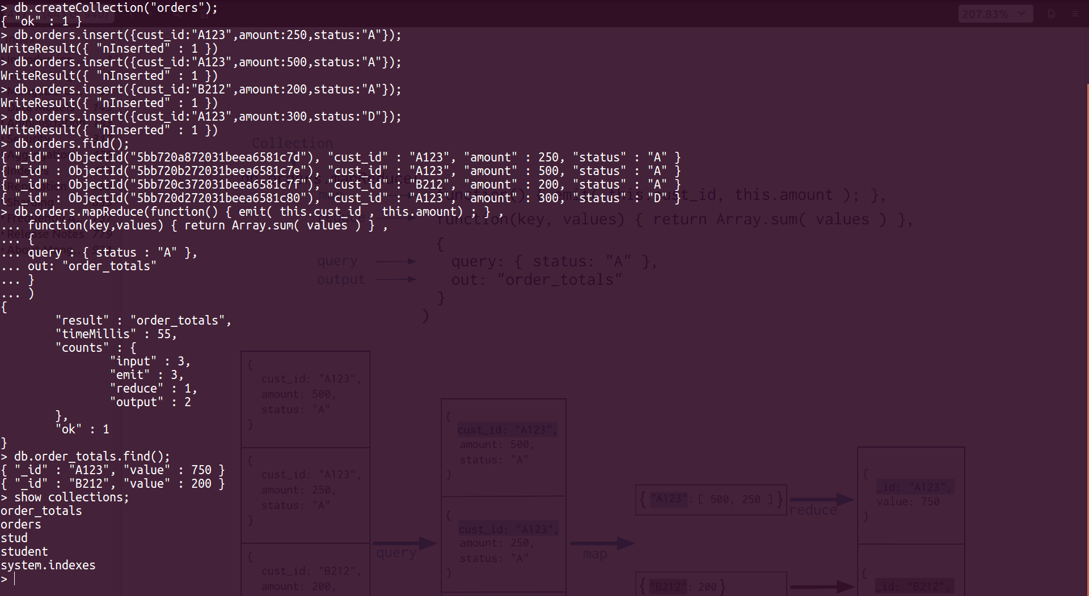

**Queries:**

Db.createCollection(“orders”);

Db.orders.insert({cust_id : “A123”, amount : 250, status : “A”});

Db.orders.insert({cust_id : “A123”, amount : 500, status : “A”});

Db.orders.insert({cust_id : “B212”, amount : 200, status : “A”});

Db.orders.insert({cust_id : “A123”, amount : 300, status : “D”});

Db.orders.mapReduce(function(){emit(this.cust_id, this.amount);},

Function(key, values){return Array.sum(values)},

{

Query : {status: “A”},

Out : order_totals

}

)

Db.order_totals.find();

Show collections;

**Conclusion:** Map reduces operation was successfully implemented in MongoDB.